## 6. Comparison with elastic analytical solution

As a first verification of the mesh convergence, numerical solutions in elasticity are made in 3D model to compare with the results obtained from the analytical and numerical solution in plane state of deformation of Guo et al [6]. These authors developed an analytical solution for the stress field around unlined twin tunnels with hydrostatic pressure in elastic medium. Fig. 12 illustrates the main parameters of the domain.

Figure 12: Parameters, domain and boundary conditions of the Guo et al. [6] analysis.

The results are shown at crown (point B) and sidewall (point A) of the tunnel considering 𝑅𝑡 = 4 m, 𝐸 = 500 MPa, 𝜈 = 0.23, 𝜎𝑣 = 𝜎ℎ = 2.2 MPa. The Fig. 13 shows the convergence profiles in the crown for various longitudinal tunnel axis distances 𝑑1 normalized by the longitudinal tunnel diameter 2𝑅𝑡 . It can be seen that the closer the longitudinal tunnels, the greater the convergence at the crown. The solution for a single tunnel was made using an axisymmetric model, but this result is also obtained using Corbetta’s analytical formulations [36].

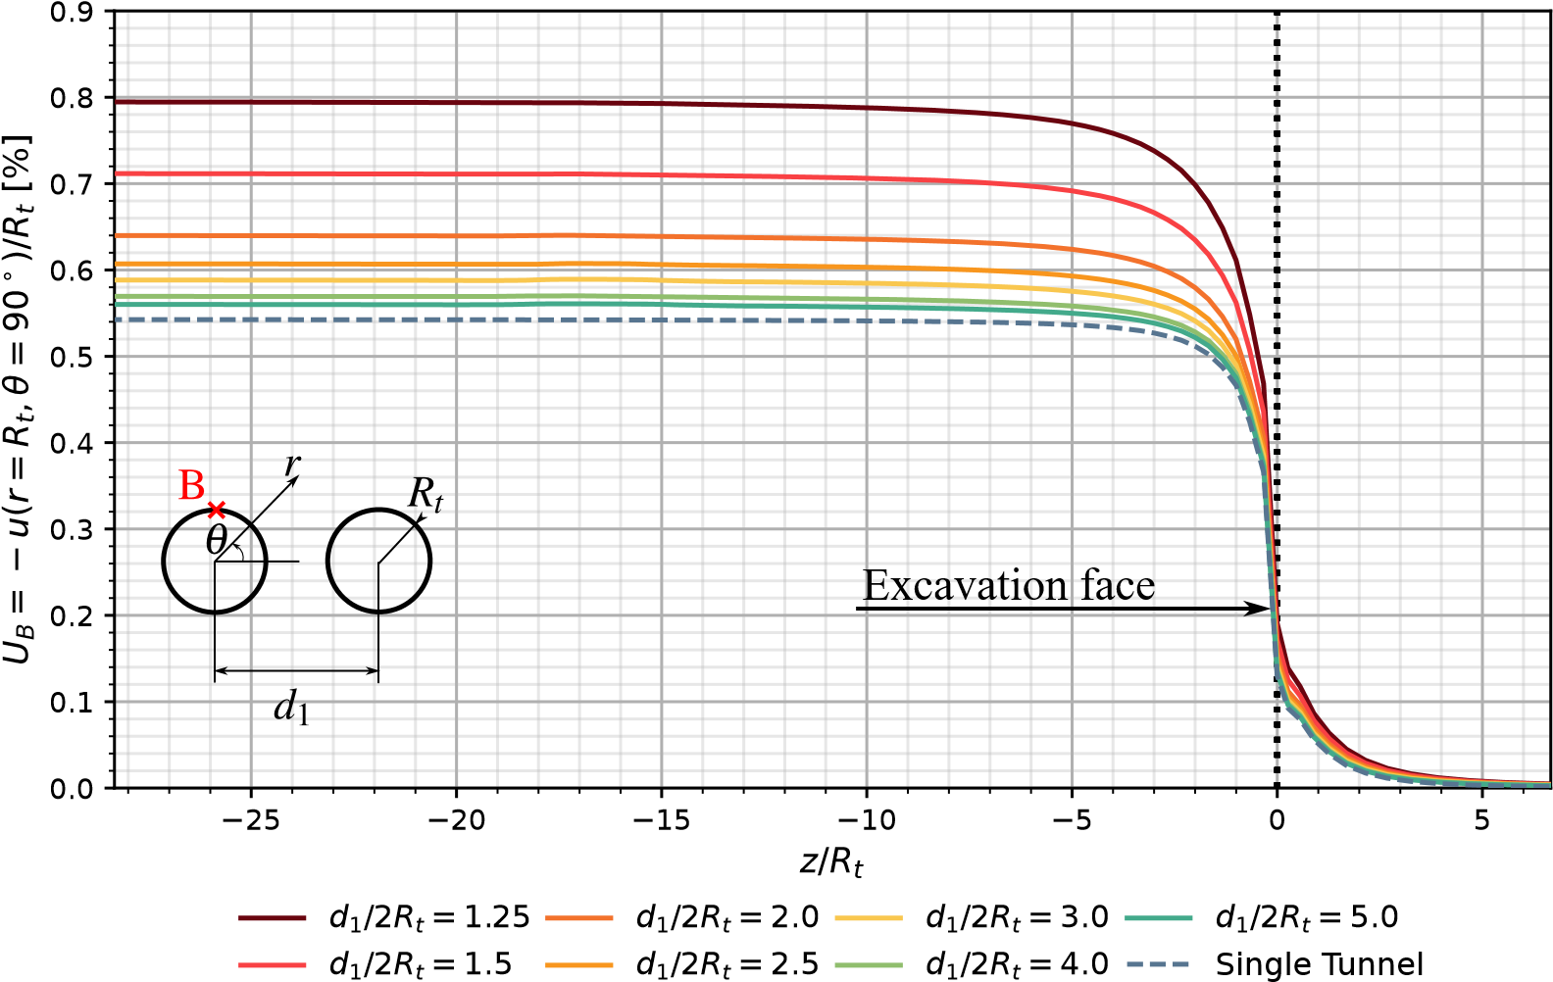Figure 13: Convergence profiles in the crown (point B).

Fig. 14 shows the relationship between the convergences in the crown and sidewall, showing the ovalization effect

that occurs when the longitudinal tunnels get closer and closer together.

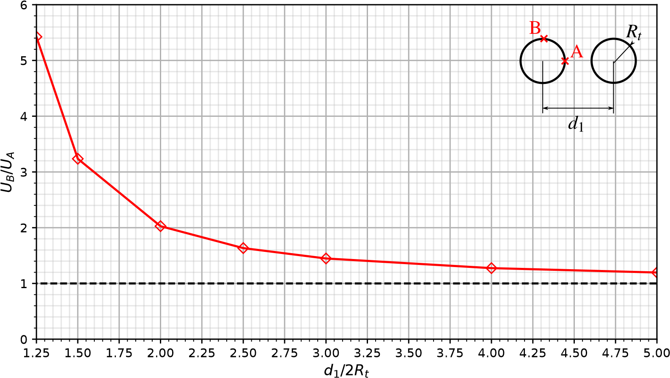

Present Analysis Single Tunnel

Figure 14: Relationship between convergence in the crown (point B) and sidewall (point A).

Fig. 15 shows the analytical and numerical solutions of Guo et al [6] (in blue and green color) together with the results obtained with the current 3D model (in red color). Ling’s solution [37], employed by these researchers to validate their analytical and numerical approaches, is also shown (in black color). Extra analyses with *𝑑*1∕2*𝑅𝑡* = 4 and 5 show that, as the longitudinal tunnels become increasingly spaced apart, the solution converges to that of a single tunnel (in dashed black color).

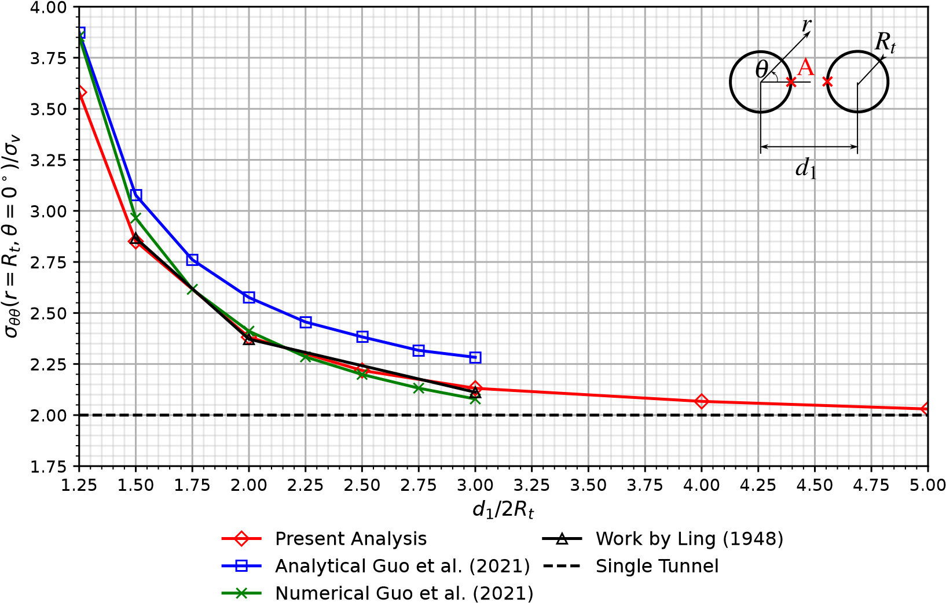

Figure 15: Tangential stress concentration factor in the sidewall (point A).

The Fig. 16 shows the comparison of the tangential stress distribution around the tunnel’s boundary considering

*𝑑*1∕2*𝑅𝑡* = 1*.*5.

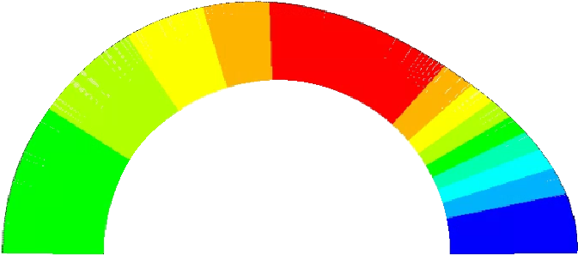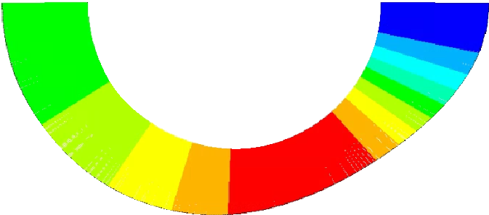

-3.80

Current

D model

3

solution

Analytical Solution

Guo, et al. (2021)

-6.30

-5.99

-5.69

-5.38

-5.07

-4.76

-4.45

-4.15

-3.84

-3.53

-5.00

-4.97

-4.13

-3.80

-3.74

-6.72

Figure 16: Verification of numerical results of tangential stresses with the analytical solution in elasticity.

## References

1. Spyridis P, Bergmeister K. Analysis of lateral openings in tunnel linings. Tunnelling and Underground Space Technology 2015;50:376–395. doi:[https://doi.org/10.1016/j.tust.2015.08.005](http://dx.doi.org/https://doi.org/10.1016/j.tust.2015.08.005)[.](http://dx.doi.org/https://doi.org/10.1016/j.tust.2015.08.005)
2. Chen F, Lin Lb, Li D. Analytic solutions for twin tunneling at great depth considering liner installation and mutual interaction between

geomaterial and liners. Applied Mathematical Modelling 2019;73. doi:[https://doi.org/10.1016/j.apm.2019.04.02](http://dx.doi.org/https://doi.org/10.1016/j.apm.2019.04.026)[6](http://dx.doi.org/https://doi.org/10.1016/j.apm.2019.04.026)[.](http://dx.doi.org/https://doi.org/10.1016/j.apm.2019.04.026)

1. Fortsakis P, Bekri E, Prountzopoulos G, Marinos P. Numerical analysis of twin tunnels interaction. In: Proc. 1st Eastern European Tunnelling Conference. Budapest, Hungary; 2012,.
2. Chortis F, Kavvadas M. Three-dimensional numerical analyses of perpendicular tunnel intersections. Geotechnical and Geological Engineering 2021;39:1771–1793.
3. Chortis F, Kavvadas M. Three-dimensional numerical investigation of the interaction between twin tunnels. Geotechnical and Geological Engineering 2021;39:5559–5585. doi:[https://doi.org/10.1007/s10706-021-01845-5.](http://dx.doi.org/https://doi.org/10.1007/s10706-021-01845-5)
4. Guo Z, Liu X, Zhu Z. An elastic solution for twin circular tunnels’ stress in hydrostatic stress field. Geotechnical and Geological Engineering 2021;39:1–11. doi:[https://doi.org/10.1007/s10706-021-01756-5.](http://dx.doi.org/https://doi.org/10.1007/s10706-021-01756-5)
5. Chortis F, Kavvadas M. 3D numerical investigation of the axial forces acting on tunnel junctions constructed in fractured/weathered to very blocky rockmass. In: Expanding Underground-Knowledge and Passion to Make a Positive Impact on the World. CRC Press; 2023, p. 1574–1582.
6. Chortis F, Kavvadas M. 3D numerical investigation of the bending moments acting on tunnel junctions constructed in fractured/weathered to very blocky rockmass. In: Expanding Underground-Knowledge and Passion to Make a Positive Impact on the World. CRC Press; 2023, p. 1583–1591.
7. Ma Y, Lu A, Zeng X, Cai H. Analytical solution for determining the plastic zones around twin circular tunnels excavated at great depth. International Journal of Rock Mechanics and Mining Sciences 2020;136:104475. doi:[https://doi.org/10.1016/j.ijrmms.2020](http://dx.doi.org/https://doi.org/10.1016/j.ijrmms.2020.104475)[.](http://dx.doi.org/https://doi.org/10.1016/j.ijrmms.2020.104475)

[104475](http://dx.doi.org/https://doi.org/10.1016/j.ijrmms.2020.104475).

1. Bažant ZP, Prasannan S. Solidification theory for concrete creep. I: Formulation. Journal of Engineering Mechanics 1989;115(8):1691–1703. doi:[https://doi.org/10.1061/(ASCE)0733-9399(1989)115:8(1691).](http://dx.doi.org/https://doi.org/10.1061/(ASCE)0733-9399(1989)115:8(1691))
2. Bažant ZP, Prasannan S. Solidification theory for concrete creep. II: Verification and application. Journal of Engineering Mechanics

1989;115(8):1704–1725. doi:[https://doi.org/10.1061/(ASCE)0733-9399(1989)115:8(1704).](http://dx.doi.org/https://doi.org/10.1061/(ASCE)0733-9399(1989)115:8(1704)) [12] ANSYS. ANSYS Programmer’s Reference, release 15.0. Canonsburg, Pennsylvania; 2013.

1. Nemat-Nasser S, Hori M. Micromechanics: overall properties of heterogeneous materials. North-Holland; 1993.
2. Deudé V, Dormieux L, Kondo D, Maghous S. Micromechanical approach to nonlinear poroelasticity: Application to cracked rocks. Journal

of Engineering Mechanics 2002;128(8):848–855. doi:[https://doi.org/10.1061/(ASCE)0733-9399(2002)128:8(848](http://dx.doi.org/https://doi.org/10.1061/(ASCE)0733-9399(2002)128:8(848))[)](http://dx.doi.org/https://doi.org/10.1061/(ASCE)0733-9399(2002)128:8(848))[.](http://dx.doi.org/https://doi.org/10.1061/(ASCE)0733-9399(2002)128:8(848))

1. de Buhan P, Fréard J, Garnier D, Maghous S. Failure properties of fractured rock masses as anisotropic homogenized media. Journal of Engineering Mechanics 2002;128(8):869–875. doi:[https://doi.org/10.1061/(ASCE)0733-9399(2002)128:8(869).](http://dx.doi.org/https://doi.org/10.1061/(ASCE)0733-9399(2002)128:8(869))
2. Marmier R, Jeannin L, Barthélémy JF. Homogenized constitutive laws for rocks with elastoplastic fractures. International Journal for Numerical and Analytical Methods in Geomechanics 2007;31(10):1217–1237. doi:[https://doi.org/10.1002/nag.595](http://dx.doi.org/https://doi.org/10.1002/nag.595)[.](http://dx.doi.org/https://doi.org/10.1002/nag.595)
3. Aguiar CB, Maghous S. A micromechanics-based approach to damage propagation criterion in viscoelastic fractured materials regarded as homogenized media. International Journal for Numerical and Analytical Methods in Geomechanics 2023;47(6):936–971. doi:[https](http://dx.doi.org/https://doi.org/10.1002/nag.3500)[:](http://dx.doi.org/https://doi.org/10.1002/nag.3500)

[//doi.org/10.1002/nag.3500.](http://dx.doi.org/https://doi.org/10.1002/nag.3500)

1. Rousset G. Comportement mecanique des argiles profondes: Application au stockage de déchets radioactifts. Ph.D. Thesis (in french); Ecole Nationale des Ponts et Chaussées; Paris, France; 1988. URL: [https://theses.hal.science/tel-00529719/.](https://theses.hal.science/tel-00529719/)
2. Nguyen Minh D, Rousset G. Influence of instantaneous failure on time dependent behavior of underground galleries. In: The 28th U.S. Symposium on Rock Mechanics (USRMS). Tucson, Arizona; 1987, p. ARMA–87–0663. URL: [https://onepetro.org/ARMAUSRMS/ proceedings-abstract/ARMA87/All-ARMA87/129838.](https://onepetro.org/ARMAUSRMS/proceedings-abstract/ARMA87/All-ARMA87/129838)
3. Giraud A, Rousset G. Time-dependent behaviour of deep clays. Engineering Geology 1996;41(1):181–195. doi:[https://doi.org/10](http://dx.doi.org/https://doi.org/10.1016/0013-7952(95)00000-3)[.](http://dx.doi.org/https://doi.org/10.1016/0013-7952(95)00000-3)

[1016/0013-7952(95)00000-3.](http://dx.doi.org/https://doi.org/10.1016/0013-7952(95)00000-3)

1. Bernaud D, Rousset G. L’essai de soutènement à convergence controlée. In: Proc. of International Symposium, Geotechnical Engineering of Hard Soils-Soft Rocks. Athens; 1993, p. 1381–1391.
2. Piepi GT. Comportement viscoplastique avec rupture des argiles raides. applications aux ouvrages souterrains. Ph.D. Thesis (in french); Ecole Nationale des Ponts et Chaussées; Paris, France; 1995. URL: [https://pastel.hal.science/tel-00523616/document.](https://pastel.hal.science/tel-00523616/document)
3. Quevedo FPM. Análise computacional das deformações em túneis profundos considerando o acoplamento plasticidade-viscoplasticidade. Ph.D. Thesis (in portuguese); Federal University of Rio Grande do Sul; Porto Alegre, Brazil; 2021. URL: [https://lume.ufrgs.br/ handle/10183/239617.](https://lume.ufrgs.br/handle/10183/239617)
4. Quevedo FPM, Bernaud D, Maghous S. Numerical integration scheme for coupled elastoplastic–viscoplastic constitutive law for tunnels. International Journal of Geomechanics 2022;22(10). doi:[https://doi.org/10.1061/(ASCE)GM.1943-5622.000251](http://dx.doi.org/https://doi.org/10.1061/(ASCE)GM.1943-5622.0002512)[2](http://dx.doi.org/https://doi.org/10.1061/(ASCE)GM.1943-5622.0002512)[.](http://dx.doi.org/https://doi.org/10.1061/(ASCE)GM.1943-5622.0002512)
5. Bernaud D. Tunnels profonds dans les milieux viscoplastiques: approches expérimentale et numérique. Ph.D. Thesis (in french); Ecole Nationale des Ponts et Chaussées; Paris, France; 1991. URL: [https://theses.hal.science/tel-00529719/.](https://theses.hal.science/tel-00529719/)
6. Perzyna P. Fundamental problems in viscoplasticity. In: Advances in applied mechanics; vol. 9. Elsevier; 1966, p. 243–377.
7. CEB-FIP . CEB-FIP model code 1990: Design code. Comité Euro International du Béton and Fédération Internationale de la Précontrainte (CEB-FIP); 1993.
8. Quevedo FPM, Schmitz RJ, Morsch IB, A. CF, Bernaud D. Customization of a software of finite elements to analysis of concrete structures: long-term effects. IBRACON Structures and Materials Journal 2018;11(4):696–718. doi:[https://doi.org/10.1590/](http://dx.doi.org/https://doi.org/10.1590/S1983-41952018000400005)

[S1983-41952018000400005.](http://dx.doi.org/https://doi.org/10.1590/S1983-41952018000400005)

1. Quevedo FPM, Bernaud D, Campos Filho A. Numerical analysis of deep tunnels in viscoplastic rock mass considering the creep and shrinkage of the concrete lining. International Journal of Geomechanics 2022;22(4). doi:[https://doi.org/10.1061/(ASCE)GM.1943-5622](http://dx.doi.org/https://doi.org/10.1061/(ASCE)GM.1943-5622.0002282)[.](http://dx.doi.org/https://doi.org/10.1061/(ASCE)GM.1943-5622.0002282)

[0002282](http://dx.doi.org/https://doi.org/10.1061/(ASCE)GM.1943-5622.0002282).

1. Quevedo FPM. Comportamento a longo prazo de túneis profundos revestidos com concreto: modelo em elementos finitos. Master Thesis (in portuguese); Federal University of Rio Grande do Sul; Porto Alegre, Brazil; 2017. URL: [https://lume.ufrgs.br/handle/10183/](https://lume.ufrgs.br/handle/10183/163886)

[163886](https://lume.ufrgs.br/handle/10183/163886).

1. Bernaud D, Debuhan P, Maghous S. Numerical-simulation of the convergence of a bolt-supported tunnel through a homogenization method. International Journal for Numerical and Analytical Methods in Geomechanics 1995;19(4):267–288. doi:[https://doi.org/10.1002/nag](http://dx.doi.org/https://doi.org/10.1002/nag.1610190404)[.](http://dx.doi.org/https://doi.org/10.1002/nag.1610190404)

[1610190404](http://dx.doi.org/https://doi.org/10.1002/nag.1610190404).

1. Bernaud D, Maghous S, Debuhan P, Couto E. A numerical approach for design of bolt-supported tunnels regarded as homogenized structures. Tunneling and underground space technology 2009;24(5):533–546. doi:[https://doi.org/10.1016/j.tust.2009.02.002](http://dx.doi.org/https://doi.org/10.1016/j.tust.2009.02.002)[.](http://dx.doi.org/https://doi.org/10.1016/j.tust.2009.02.002)
2. Maghous S, Bernaud D, Couto E. Three-dimensional numerical simulation of rock deformation in bolt-supported tunnels: A homogenization

approach. Tunneling and Underground Space Technology 2012;31:267–288. doi:[https://doi.org/10.1016/j.tust.2012.04.008](http://dx.doi.org/https://doi.org/10.1016/j.tust.2012.04.008)[.](http://dx.doi.org/https://doi.org/10.1016/j.tust.2012.04.008)

1. Zienkiewicz O, Cormeau I. Visco-plasticity—plasticity and creep in elastic solids—a unified numerical solution approach. International Journal for Numerical Methods in Engineering 1974;8(4):821–845. doi:[https://doi.org/10.1002/nme.v8:4](http://dx.doi.org/https://doi.org/10.1002/nme.v8:4)[.](http://dx.doi.org/https://doi.org/10.1002/nme.v8:4) [35] Simo JC, Hughes TJR. Computational Inelasticity. Springer-Verlag; 1998.
2. Corbetta F. Nouvelles méthodes d’étude des tunnels profonds: calculs analytiques et numériques. Ph.D. Thesis (in french); Ecole Nationale des Ponts et Chaussées; Paris, France; 1990. URL: [https://theses.fr/1990ENMP0227.](https://theses.fr/1990ENMP0227)
3. Ling C. On the stresses in a plate containing two circular holes. Journal of Applied Physics 1948;19(1):77–82. doi:[https://doi.org/10.](http://dx.doi.org/https://doi.org/10.1063/1.1697875)

[1063/1.1697875.](http://dx.doi.org/https://doi.org/10.1063/1.1697875)